OASIS BI Pending Fixed Asset Report WV-FIN-AM-043 Fixed Asset Documents
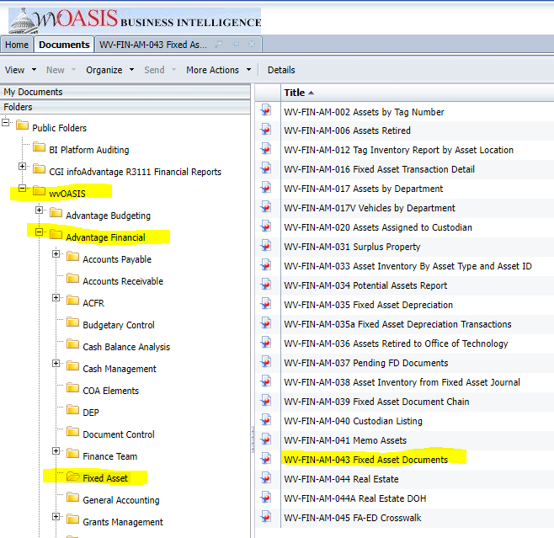

The cover page will list the different Doc Phase Code values.

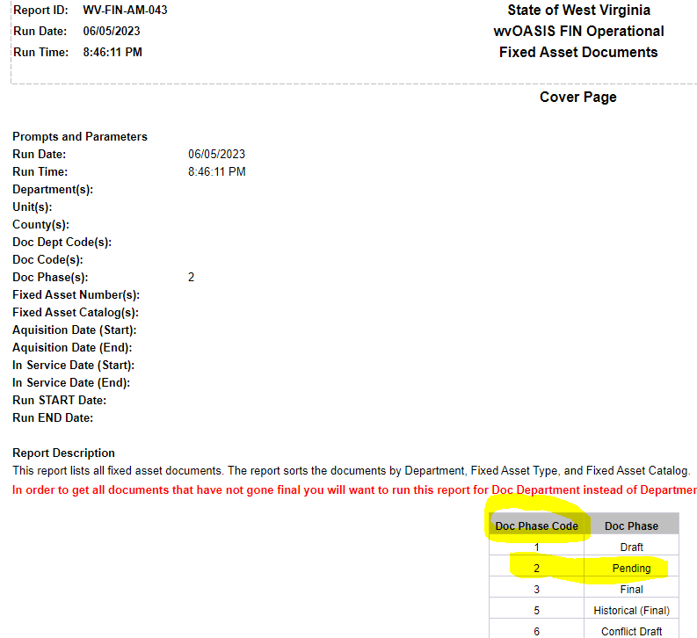
When refreshing the report use the prompt for Document Phase Code = 2 for PENDING documents.
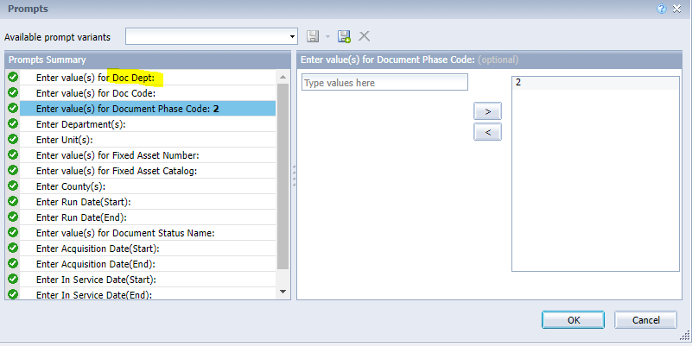

To select a specific dept code use the 1st prompt for “Doc Dept”. The reason is because there are records that have a ‘blank’ Dept and Unit fields but the Doc Dept is always populated. See example below.
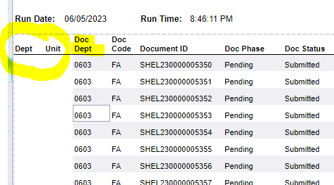

The report can be exported to excel.
